Issue Tracker: E000411

Type: Enhancement

Brief Description:

Workspace ticket# enhancement

Description:

The Ticket # in the email Notification should be a Hyper link and when user click on the number, should redirect to WMS and open the Ticket details and If user didn’t login to WMS, redirect to WMS login page and after logging in, open the ticket details.

Acceptance Criteria:

* When a user creates a Ticket, or a Ticket gets assigned for a user or if a user is added to the ticket as Requestor, then an email notification will be sent to the user.
* This email notification will have ticket details and in this the Ticket number should be Hyperlink. When the user clicks on this, it should re-direct to tickets page i.e. All Tickets or Archive Tickets or Non Panel or LOA Tickets or Dormant Tickets wherever the ticket is laying. And should open the ticket details pop-up screen.
* If user isn’t logged in WMS 2.0, then re-direct user to login page & once the user logs in. open the ticket details page.
* If the user does not access to Non Panel or LOA Tickets or Dormant Tickets tabs, then when the user logs in display a pop-up message as “*The* ***TKT#XXXXXX*** *is in Non Panel/LOA Tickets/ Dormant Tickets tab*”.

Issue Tracker: E000411

Type: Enhancement

Brief Description:

Duplicate Lineitems are getting added

Description:

when a duplicate lineitem is added to a Baseline (Based on the Equipment number), system should prompt to add a reason on why the duplicate lineitem is being added, and create an Approval workflow.

Acceptance Criteria:

* When user tries to add a new lineitem or update a lineitem cross check with ‘*Spend Category’*, ‘*Service Type’*, ‘*Equipment’*, ‘*Size’*, ‘*Service Category’*, ‘*Waste Type’* and ‘*Vendor Description*’ fields of existing lineitems which are in ‘*Active’*, ‘*Extras’* & ‘*Archived*’ tabs.
* User manually enters Vendor Description, enable like search for the words entered. For example, if user enters ‘*Admin Fee*’ check for lineitems which has words as *Administrative*, *Admin* & *Fee*.
* If any of these words matches then display the lineitems with these words in the pop-up message.
* If the newly added lineitem matches with all the above fields, then open pop-up screen with message as “*The line lineitem you are trying to add matches with ‘****existing lineitem vendor description****’*. *Do you still want to add the lineitem?*”. This pop-up screen should have buttons as ‘Yes’ & ‘No’.
  + When clicked on ‘**Yes’**, then user must add a reason in the comment box as mandatory. After hitting ‘Yes’, the lineitem should fall in approval queue.
  + And if user hits ‘**No’**, then close the pop-up screen. User will go back to add or edit lineitem screen.
* Even if any one of the following fields ‘*Spend Category’*, ‘*Service Type’*, ‘*Equipment’*, ‘*Size’*, ‘*Service Category’*, ‘*Waste Type’* and ‘*Vendor Description*’doesn’t match then add lineitem directly.
* Add a page as “**Lineitem Approvals**” in Settings module just like ‘Account Approvals’.
* When user clicks on this, open a page which has grid with following columns
  + Client Name
  + Property Name
  + Vendor Name
  + Baseline ID
  + Baseline Status
  + Existing Lineitem (Display existing lineitem description i.e., duplicate one)
  + New Lineitem (Display New Lineitem description)
  + Reason (Comments entered by user whiling adding lineitem)
  + Negotiation ID
  + Negotiation Status
  + Contract ID
  + Contract Status
  + Actions (edit icon)
* When user clicks on edit icon, open a pop up where user enters comments & chooses to ‘Approve’ or ‘Reject’.
* If approved lineitem gets added & if rejected, then the lineitem will not be added.
* This “**Lineitem Approvals**” page will be enabled to user by access.

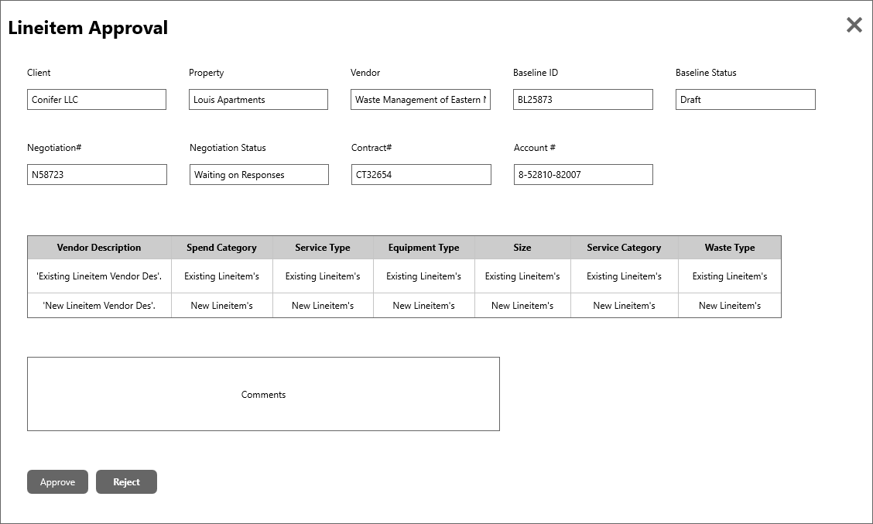

* Changes made for the lineitem should only reflect after approval & disable the ***Edit*** icon of the lineitem which is in approval queue. User should not be able make further changes in all pages i.e., Baselines, Negotiations & Contracts until Approved or Rejected.
* When user tries to edit this lineitem, prompt a message as “*Lineitem is waiting for Approval in Lineitems Approval Queue*”.
* This functionality should be implemented in Baselines, Negotiations (while adding baseline lineitem) and Contracts. and here are the pages
  + Add Baseline
  + Edit Baseline
  + Review Baseline
  + Approve Baseline
  + Request Bid
  + Evaluate Bid
  + Approve Bid
  + Validate Contract
  + Edit Contract
  + Transmit Contract
* System should not allow user to approve baseline when a lineitem is in **Lineitems Approval** queue. Prompt a message as “***lineitem vendor description*** is in Lineitem Approval queue”, when user tries to approve baseline.
* Invoice should not be processed until baseline is moved to Approved status.

Issue Tracker: E001075

Type: Enhancement

Brief Description:

Create a total tickets report with all tickets; open and archived. Create widget or dashboard

Description:

Would a report enable the user to pull all tickets; both open and closed. Additionally create a widget or view copying the attached with summary data.

Acceptance Criteria:

* Create a report for tickets by category. Name the Report as ‘Total Tickets Report’.
* Provide same search filters which are in Tickets tab. Include Dormant & Archived tickets too.
* Make search by ‘*Client Name’* or ‘*Ticket Created Date* Range’ *or ‘Completed Date Range’* as mandatory search fields. If the Date range is selected it should not exceed more than 12 months.
* If user selects Status, then display selected status tickets or else display all tickets both open & closed.
* This report should display count of tickets by Created Date & Category as the screenshot below.
* Add ‘*Tickets Category*’ as column names & ‘*Created Date’* as row names.
* Add Total at end column & End row. This should display sum of tickets count in the respective row & column.
* Make the counts as hyperlink & when user clicks on it open grid with tickets details. (replicate All tickets grid). User should be able to download this data in in .xlsx, csv, pdf. And the ticket number here should be hyperlinked & when clicked open ticket detail pop-up screen.
* Add options to download the data in .xlsx, csv, pdf.

Issue Tracker: I001085

Type: Enhancement

Brief Description:

Report export

Description:

Payfiles - Unmatched Transactions - when we filter - if you download to CSV it works, if you download to Excel you get the full unfiltred report.

This is happening on other reports as well. Check All Open Invoices as well

* When users apply column level filters to reports, tickets or any other pages in WMS 2.0 (where ever it is applicable) and download data in (.xlsx), the downloaded data isn’t filtered.
* Data in the sheet should be as per the filters applied.

Issue Tracker: E001109

Type: Enhancement

Brief Description:

Add the "Select client" choice when creating tickets

Description:

We have the ability to select accounts and/or properties and create multiple tickets without having to repeat the process multiple times. If we added in the ability to "select client" and automatically create a ticket for each client selected, this would greatly reduce the time/effort it takes to create tickets for monthly reporting or other bulk actions that we have to complete for all of our clients where a separate ticket is needed but all of the other information is the same.

Acceptance Criteria:

* While creating a ticket, if user selects multiple properties, based on the number of properties selected, the number of tickets will get created.
* Add a multi-select dropdown option to the client filed in create ticket page.
* Based on the number of clients selected, system must create that number of tickets. And each ticket should have the client tagged.
* If 2 or more Clients selected, then display Properties and Accounts as per selected Client.
* If user selects 2 clients and 1 property from under each client & 2 accounts under each property, then create 4 tickets by combination of Client related its property & account. Then create 4 tickets. We already have this functionality existing for Properties & Accounts, do implement the same for Clients.

Issue Tracker: E001143

Type: Enhancement

Brief Description:

Bank Recon - add subtotals by account, add total for overall deposits

Description:

Bank Recon - add subtotals by account, add total for overall deposits

Acceptance Criteria:

* Under each Account section add a row as Total & display the totals of ‘*Deposits From the Bank*’, ‘*Uploaded in WMS*’, ‘*Custom Amount’*.
* Now at the bottom of the entire screen, add a row as Grand Total & display the totals of ‘*Deposits From the Bank’*, ‘*Uploaded in WMS’*, ‘*Custom Amount*’ from all accounts.

Navigation: Garage< Actions < Payment Manager < Bank Reconciliation Report < edit deposit.

Issue Tracker: E001219

Type: Enhancement

Brief Description:

add County information

Description:

If the system has the zip code can the system prepopulate the county off the zip code? We need to be able to look at properties per the county.

Acceptance Criteria:

* Add a filed as ‘County’ next to city in address pages of Client, Property, Vendor Corporate & Vendor Local.
* Add the same field as county next to city in Client List Report, Property List Report, Vendor Corporate list Report & Vendor List Report.
* The County should auto populate by the entered ZIP code.
* Attached the sheet to with ZIP codes & Countys.

Issue Tracker: E001144

Type: Enhancement

Brief Description:

Bank Reconciliation - Reporting for specified time frame

Description:

Need to be able to generate reporting on specified time frame. Totals by account by day by month etc.

Acceptance Criteria:

* Provide search fields as ‘*Deposit Date Range*’, ‘*Bank Account*#’ and ‘*Status*’.
* Create a report which shows Bank Deposits by date.
* Include the following columns ‘*Banks Accounts#’,* ‘*Deposit Date’, ‘Deposit Type’, ‘Deposit from Bank’, ‘Uploaded in WMS’, ‘Custom Amount’, ‘Delta’, ‘Rec Notes’ and ‘Status’*.
* Add a ‘***Deposit*** ***Date****’* column next to ‘*Bank Account#*’ and display deposit dates in this column.
* Add another column as ‘***Status’*** next to the Reconciliation Notes. Display the status of Deposits “*Draft*” or “*Finalized*”.
* Under each Account section add a row as Total & display the totals of ‘*Deposits from the Bank*’, ‘*Uploaded in WMS*’, ‘*Custom Amount’* of an account by Deposit Date.
* Now at the bottom of the every Deposit date section, add a row as Grand Total & display the totals of ‘*Deposits From the Bank’*, ‘*Uploaded in WMS’*, ‘*Custom Amount*’ from all accounts of by Deposit Date.
* User should be able to download each deposit in .xlsx, .csv or pdf. Hence add icons at the top right corner of the page .to download the data.
* All these data can be replicated from Bank Reconciliation Report. Navigation : Garage < Actions < Payment Manager < Bank Reconciliation Report < Edit to open.
* Below is the mock visual of the report.

Issue Tracker: E001185

Type: Enhancement

Brief Description:

AP Report on Open Hauler Invoices

Description:

Report that will be ran separately from AR, that will isolate all open hauler invoices. This will ensure that if for some reason an invoice is not funded, but still needs to be paid to the hauler. The AR is only showing it based on payments we have received but not necessarily if we actually paid the hauler.

Acceptance Criteria:

* This report should be only for Bill Pay clients.
* Add search fields *Client, Property Name, Account#, Invoice#, Vector Invoice, PayFile Name, Payment Status, PayFile Generation Date,* and an option to filter *Unpaid Transactions*.
* Create a report which has grid with following columns
  + Client
  + Property
  + Vendor
  + Account#
  + Invoice#
  + Vector Invoice#
  + V97 Approved
  + Vendor Payment Received
  + CI Status
  + Pay File Status
  + Pay File Name
  + Paid Date
  + Payment Type
  + Comments
  + Actions
* Replicate this report from Payfile Transactions Report.
* In comments display the comments from Unmatched transactions or Void Invoice.
* In Actions add an ‘*Mark as Settled’* icon, when clicks on this open a popup screen which allows user to settle a transaction. (replicate this action from Unmatched Transactions- Payment Manager).

Issue Tracker: E001279

Type: Enhancement

Brief Description:

Need Reference Field added for manual matching

Description:

When we manually map a payment to an invoice, we need to be able to enter the reference number so we can search for this payment by the check number/reference number

Acceptance Criteria:

* In payment manager panel there are tab as
  + Unmatched Transactions
  + All Open Invoices
  + My Queue
* In all these tabs, there are actions column.
* When user clicks on edit, a pop opens with a grid. In this grid add a column as “***Reference Code***”.
* This Reference Code column should be a text field, where user enters Reference Code for Manual transactions.
* This Reference Code should reflect under Ref. code column in Payment Settlement Report. And user should be able to search this using ‘***Statement Ref. Code’*** search field.
* In *Unmatched Transactions* tab, when user clicks on edit, a pop opens with a grid and this column with text fields should be added next to ‘V97($)’ column.
* In *All Open Invoices* tab, when user clicks on edit, a pop opens with a grid, add text filed in the *‘Ref#*’ column & move this column next to ‘*Conf. File Name*’ column.
* In *My Queue* tab, when user clicks on edit, a pop opens with a grid, add text filed in the *‘Ref#*’ column & move this column next to ‘*Conf. File Name*’ column.

Issue Tracker: E001279

Type: Enhancement

Brief Description:

Need to add vendor service areas and the radius.

Description:

When a hauler gives specs below is there a way that we could build out or have a way in the system to know that they service the areas AND that the radius or no?

Acceptance Criteria:

* In Vendor local we have ‘*Edit Vendor Info*.’, we have a tab as ‘***Vendor Services’***.
* To add a Vendor Service user clicks on ‘Add’ icon & a popup pages open, changes ‘*Service Type*’ to ‘*Equipment Type*’.
* This ‘*Equipment Type*’ will be a dropdown with multi-select options.
* When user selects multiple options, display the values in the grid as comma separated.
* This grid & values should be reflected same in ***View Vendor*** too.
* Add options to download this data in excel, csv & pdf.